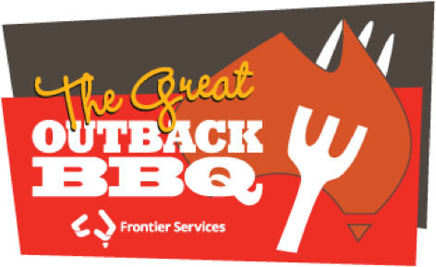
A GREAT OUTBACK BBQ

for Frontier Services
is to be held on
Saturday 5 November, at 4.00pm
Redlands Uniting Church–Cleveland.

BOOK THIS DATE IN YOUR DIARIES NOW!

INVITE: FAMILIES FRIENDS NEIGHBOURS

WEAR YOUR AKUBRA

ENTERTAINMENT

TRIVIA and SING-ALONG

BBQ DINNER

$5.00 per Adult $2.00 per Child

Who We Are
We live in a society where people are more isolated, and there’s less contact.
Especially people who live in the bush. We are the companion who turns up
out of the blue to lend an ear, give a helping hand, and be of service.
It’s the Australian way of giving everyone a fair go, and helping other folk.
And as Australia’s oldest bush charity we’ve been doing it for more than 100 years.

Our Purpose

For The Love Of Helping People
We are an agency of the Uniting Church in Australia and we do what we do
for the love of helping people. Helping people is human nature. If I can help
anyone I will – even if it’s just a smile and saying, “Howdy”. Frontier
Services is about making this life connection between people. A telephone call
and a chat. A friendly face. A listening ear. A helping hand. It’s called mateship. And it happens on an emotional, a physical, and a spiritual level.

Our Vision
We dream of an Australia where everyone who lives in our regional and remote areas are cared for and supported and have a mantle of safety and well-being.
Australian people who live out bush experience the tyranny of distance
and social isolation. These include indigenous communities, isolated properties,
mining communities, and other remotely located communities. And for them,
we are the people who knock on the door, take the time to listen,
offer a helping hand and be of service.

Our Bush Chaplains And Their Remote Areas
Our Bush Chaplains cover a large area of remote Australia, but there are still gaps to fill. We’re working hard to cover even more of the country.

